­Software Engineering Group Project

Career Planning Application

|  |  |
| --- | --- |
| Authors: | Aidan Broomfield-Harris [aib17], Maciej Reniewicz [mar117], Samuel Bannister [sab80], Yi Xu [yix5], Sean Cox [sec24] |
| Config Ref: | AGP_MSC_21 |
| Date: | 12th April 2021 |
| Version: | 3.0 |
| Status: | Draft |

Department of Computer Science

Aberystwyth University

Aberystwyth

Ceredigion

SY23 3DB

Copyright © Aberystwyth University 2021

CONTENTS

CONTENTS 2

1. Introduction 3

1.1 Purpose of this Document 3

1.2 Scope 3

1.3 Objectives 3

2. DESCRIPTION 3

2.1 Overview 3

2.2 Initial Research 3

2.2.1 The Balance Careers Planning [1] 3

2.2.2 Occupational Outlook Handbook [2] 4

2.2.3 MyPlan.com [3] 4

2.2.4 Career Key [4] 4

2.2.5 The Career Project [5] 4

2.3 Scrum Methodology 4

2.3.1 Reviews and Retrospectives 4

2.3.2 Definition of Done 5

2.4 Functional Requirements 6

2.5 User Interface 6

3. User manual 8

3.1 INSTALLATION AND SETUP 8

3.1.1 Installation 8

3.1.2 Running the Program in Windows(Without Python) 8

3.1.3 Running the Program in Python 8

3.2 USING THE PROGRAM 9

3.2.1 Profile Page 9

3.2.2 Application Pages 9

3.2.3 Careers Interest Page 12

3.2.4 Learn More Page 13

4. Data structures and Algorithms 13

4.1 Overview of Coding Approach 13

4.2 Using PyQt5 to build a GUI 13

4.3 Profile Page Functions 14

4.4 Application Pages Functions 14

5. Verification and Testing 15

6. Future Work and Improvements 16

REFERENCES 16

DOCUMENT HISTORY 17

# Introduction

## Purpose of this Document

The purpose of this document is to detail the process and utility of the application we have implemented for our MSc Group Project. In this project we built a software product that helps to support career planning. This document provides a brief description of what the software does and how it does it. It then gives instructions of how to use the product. It also provides a discussion on which algorithms were used to implement the software. Lastly it shows the evidence that the software has been tested and evaluates the finished product.

## Scope

This project was implemented following the Agile Methodology of Scrum. We started by researching the Scrum principles, defining the meaning behind the term “done” and ensuring that all group members were on the same page.

## Objectives

This project required a system that allows a user to be introspective, highlighting their strengths and weaknesses.

Therefore it must have a page for the user to build a “Profile”, storing their choices with evidence to support their claims. They must also be given the option to learn more about how to realise their own character traits. This can be implemented through use of a “Learn More” page.

Next we need to provide the user with a place to store information regarding their “Career Interests”, with reference to potential employers, sectors and job types. There should be an option for the user to view their profile by the side of their career interests, so that they can relate any key requirements for those positions.

# DESCRIPTION

## Overview

Building on the objectives in 1.3, the application was designed to give the user the ability to find out more about themselves, whilst guiding them in this process. This software takes a set of input from the user regarding their personal details, career interests, skills and jobs that they have applied for and stores these variables in a database.

In the spirit of Scrum, we planned our first sprint to come after we had a chance to chat amongst ourselves as a team. We prioritised sharing our thoughts about the project and creating good team cohesion before diving straight into the thick of it. This allowed us to place important artefacts into the product backlog, which in turn allowed for a smooth first sprint.

## Initial Research

The research we did at the beginning of the project was based on looking at existing Career Planning platforms and attempting to gain an understanding of the way they worked. It allowed us to extract features that we saw as useful to implement within our own application.

The sites that we researched are below and under each sub-heading are the main ideas we realised from each platform.

## The Balance Careers Planning [1]

This website breaks down the steps for career planning. Firstly it allows you to conduct a self-assessment where it evaluates your strengths and considers your enjoyments, what drives you crazy, who you are as a person, who you desire to be as a professional. Then it looks at your work, school and volunteer experiences following on with your career value, interests, skills and personal qualities.

Next it allows you to brainstorm possible job options and investigate them. There is a list of jobs with their appropriate descriptions and qualifications with typical entry requirements and advancement opportunities. Lastly, it offers you a way to list the pros and cons and to create a shortlist of most interesting job ideas.

## Occupational Outlook Handbook [2]

The occupational handbook is an American website which allows you to browse by occupation groups, being able choose between the criteria of highest paying, fastest growing (projected), most new jobs (projected) and field of degree. You can also select by entry-level occupation and median pay.

We thought that this did not represent the type of platform that fitted the requirements of our project brief, yet it provided useful insights.

## MyPlan.com [3]

This site offers a series of different tools. The first is an Interest Inventory, there are 75 questions and compares it against 739 different careers. The test lasts for 25 minutes, it's online and costs 9.95. The other three are Career Skills, Career Values and Career Personality tests. Personality has 60 questions, on matchmaking, teambuilding, self-actualization.

We do not plan to have any quizzes on our site, yet the idea of having career skills that the user is able to place within their profile strikes us as a good design choice.

## Career Key [4]

The career key personality and career test is based on Holland’s theory and costs $9.95.  Careerkey.org also has information about changing careers, job satisfaction, choosing a major and  identifying your skills. They have online career decision profile creation with a 5-min completion time with clear explanation of assessment results.

Keeping a simple and fast profile creation with opportunity to expand in other parts of the application is another feature we thought would be useful.

## The Career Project [5]

This site offers thousands of career profiles from people that actually work in those professions. Workers report information about income, benefits, work environment, and job satisfaction. You can also view a day in the life, where users detail their workdays hour-by-hour. They also offer various personality tests, including the well-known 16 types model.

## Scrum Methodology

Another key factor that makes up this project is the use of the Agile Methodology of Scrum. Scrum is framework where teams can efficiently address complex and changing requirements of a software project.

A benefit of Scrum that we found early on was when solving a problem of having a different understanding of the brief. The issue was that some team members thought that the brief asked for an application that allowed for the explicit searching of and applying to various real jobs. Whereas the other team members thought that it was an application that allowed for the storing of information about applying to jobs, and acted as software to help track the process. This was helped by Scrum in that the methodology’s inherent process calls for regular team talks (daily Scrums) and the ability to change the product backlog with ease. These allowed us to realise a problem, clarify it with the customer and push a revised solution to the backlog quickly.

## Reviews and Retrospectives

Our Scrum Master Sean created a table to show how we would organise our Sprint Reviews.

## Macintosh HD:Users:aidanbroomfield:Desktop:Screen Shot 2021-04-12 at 14.52.01.png

## Macintosh HD:Users:aidanbroomfield:Desktop:Screen Shot 2021-04-12 at 14.52.15.png

Then Sean created a Sprint Retrospective table,

## Definition of Done

Our Scrum Master also then provided a visual overview of our agreed definition of done.

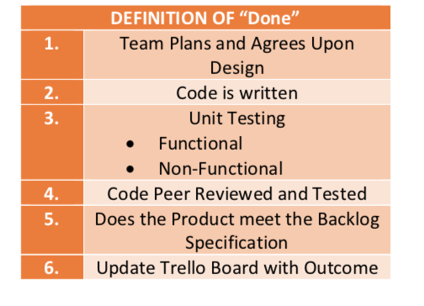

## Functional Requirements

The prior research along with group discussions allowed us to come up with a series of functional requirements, which we could use to move forward with the project. As we were working in an Agile manner these were open to changes throughout the course of the project, yet there acted as a good base to begin development.

* **FR1** **–** The software should provide links to useful resources, with regards to introspection and self-discovery.
* **FR2** **–** The user should be able to record their conclusion to their strengths and weaknesses, with evidence supporting the conclusion.
* **FR3** **–** The software allows the user to keep track of potential employers, sectors and positions they aim to secure.
* **FR4** **–** The software will link the key requirements of a job to the user’s skillset.
* **FR5** **–** The software allows the user to track applications made and their outcome.
* **FR6** **–** The software can filter applications by location (A requirement added mid-project).

## User Interface

In this section, we follow the path of our initial ideas regarding the project brief and application design. We came up with a series of UI designs that conceptualised the acceptance criteria, which we had discussed before going into the first sprint. We discussed the needs of the project and made freehand sketches as a way of observing how the software could look. We then put these into three example UI designs, as seen in AC1, AC2 and AC3. “AC” stands for acceptance criteria.

Based on the designs, one of our developers created an example page that the other developers could use as a base for making the other pages.

AC1 -

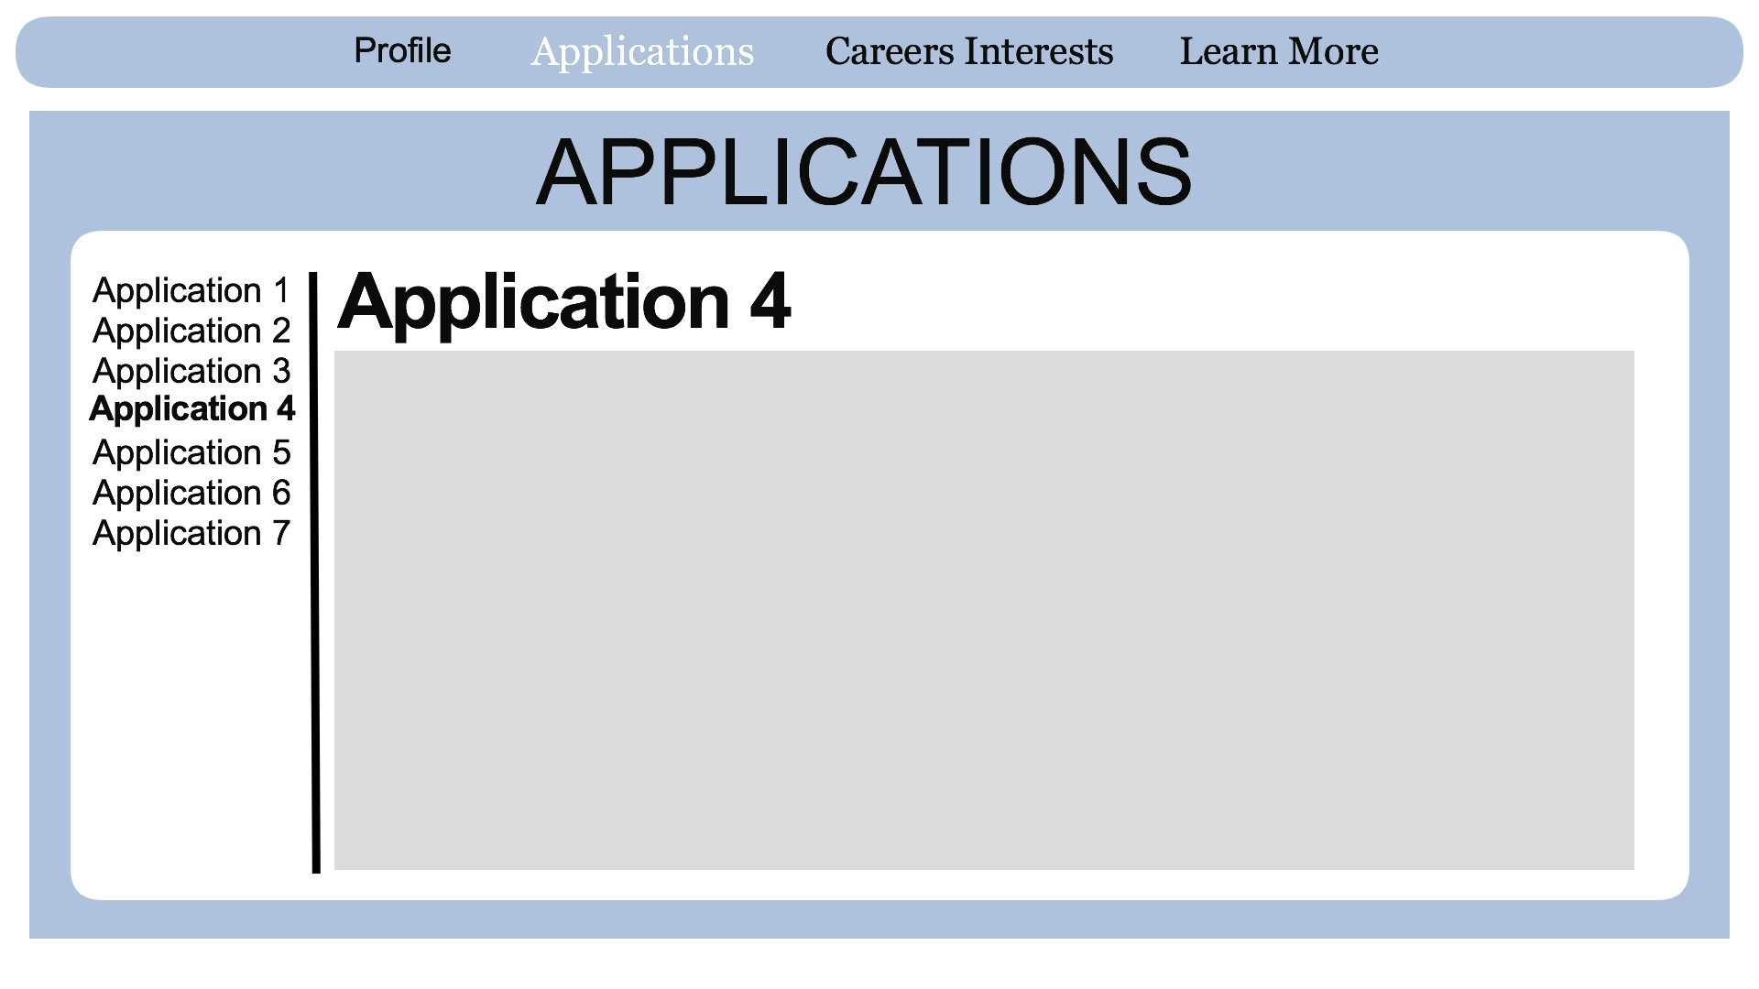

AC2 –

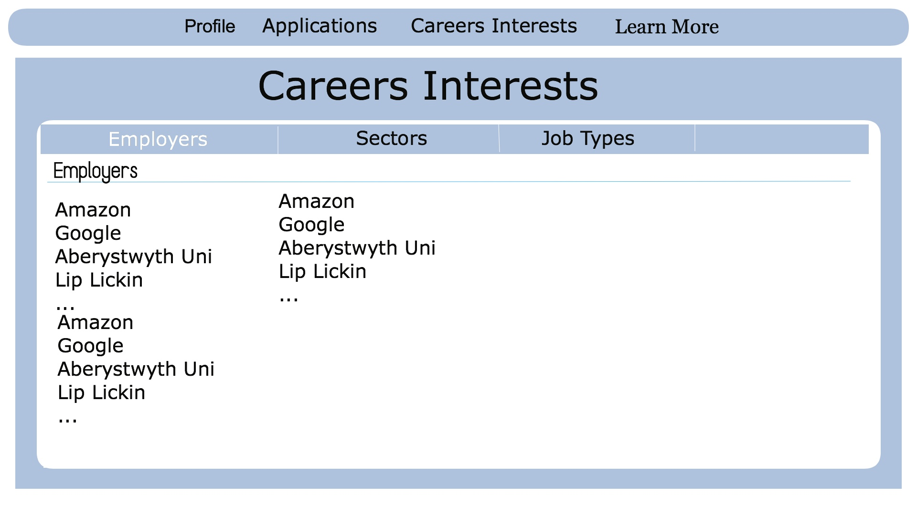

AC3 -

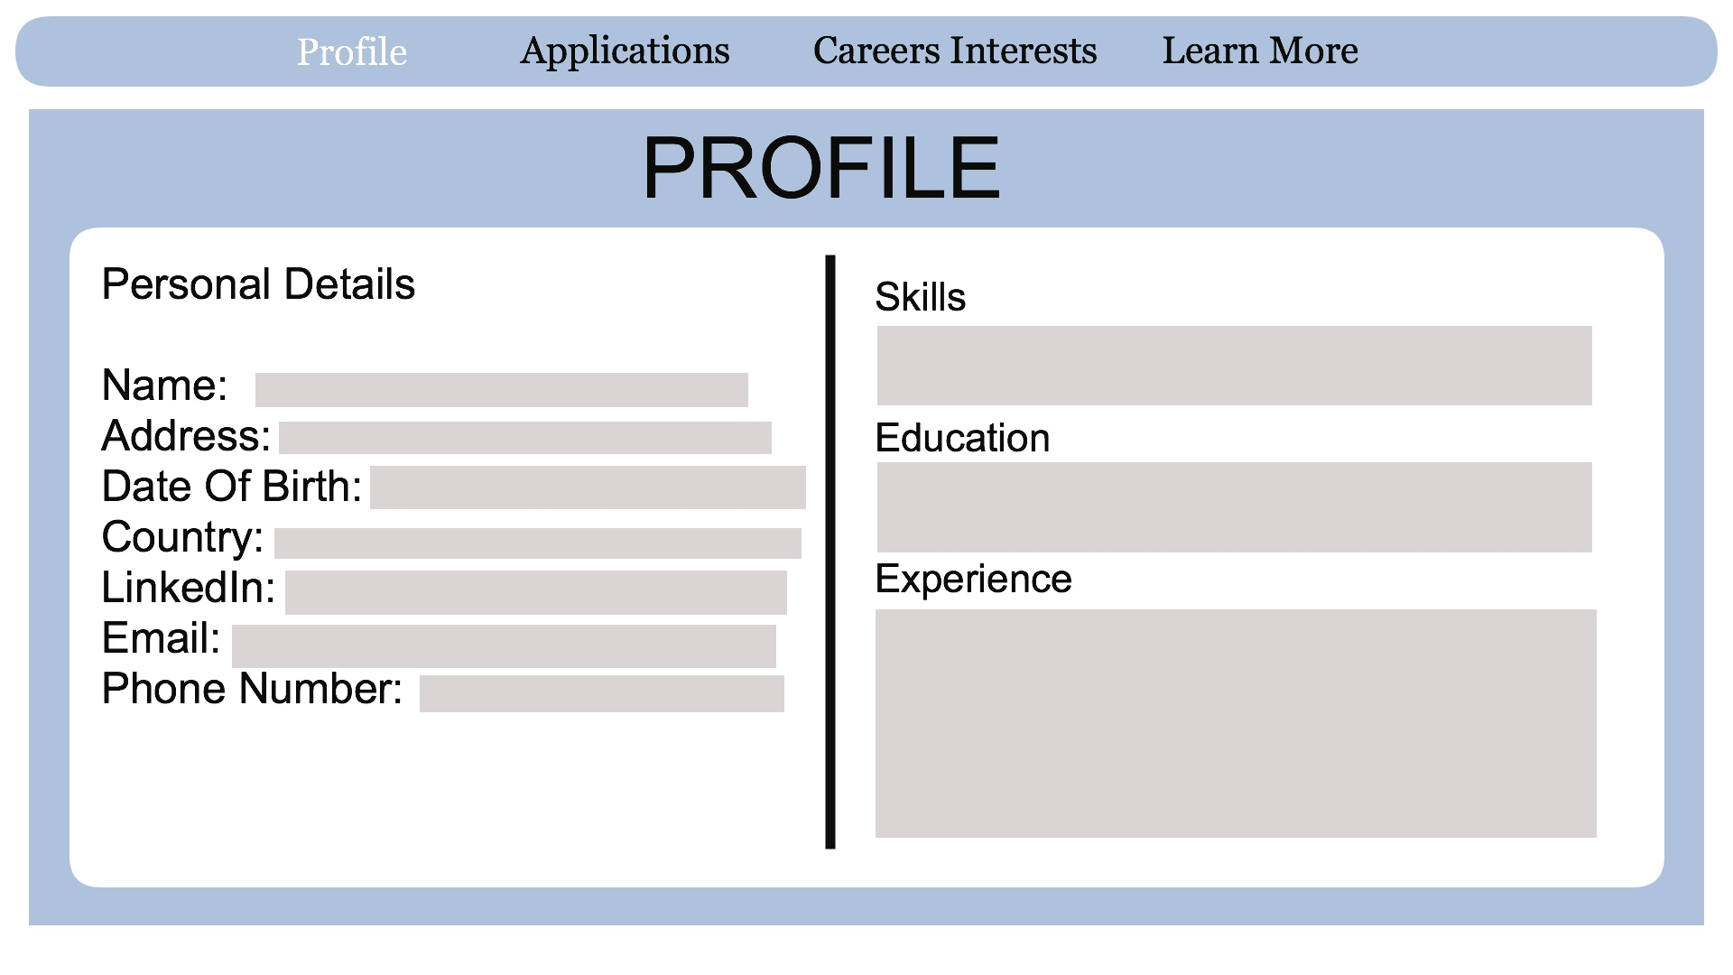

From here we had 5 prototype pages, one for each of the main areas of the application. As described in our sprint backlog, the acceptance criteria for having each page “done”, was a version of the page that showed resemblance to the UI designs that we had come up with prior.

After completion of the acceptance criteria (being that a prototype of each page that had the look and feel of our UI designs) we then moved to amalgamating the pages under a single python file.

# User manual

## INSTALLATION AND SETUP

## Installation

**Extracting the Program:**

* Download the ‘CareerPlanner.zip’ file.
* Move the .zip file to your desired location
  + eg. Home/user/Documents
* Once in your desired location, right click the .zip file.
* Then click ‘Extract here’
  + This option may be worded differently on other systems, but will produce the same result.
* Now you should have two new files within the same folder, both named ‘CareerPlanner’.One will be a Windows Executable (.exe) and the other a Python Script(.py).

## Running the Program in Windows(Without Python)

Running the program in Windows is extremely streamlined. All the user needs to do after extracting the files, is to double click the .exe file and the program will run in its own window.

However the user is not restricted to using this method alone. The following section covers how to run the program within the Python Interpreter. Which is useful if the .exe file isn’t working, or the user is on MacOS or a Linux system.

## Running the Program in Python

**Installing PyQT5:**

**The PyQT5 library is essential for the .py to run.**

* Open the terminal
  + Windows open start menu and search for ‘Command Prompt’. P**lease ensure beforehand you have downloaded and installed the Python interpreter from https://www.python.org/downloads/windows/**
  + **Linux click the key combination (ctrl+alt+t)**
* **Type ‘pip install PyQT5’ or ‘pip3 install PyQT5’.**

**The Easier Method(LINUX):** Tested on Ubuntu 20.4 LTS

* Right click on an empty space/background within the file explorer
* Click ‘Open in Terminal’
* Type ‘Python CareerPlanner.py’ and click enter.
* Then the program will open in a new window.

**Universal Method:** Can be used on most platforms including Windows (providing you have previosuly installed Python into your Windows machine).

* Open the terminal
  + Windows open start menu and search for ‘Command Prompt’
  + Linux click the key combination (ctrl+alt+t)
* type ‘cd ’ then the location of the .py file
  + I.e home/user/documents/
* Then type ‘python CareerPlanner.py’ and click enter.

## USING THE PROGRAM

## Profile Page

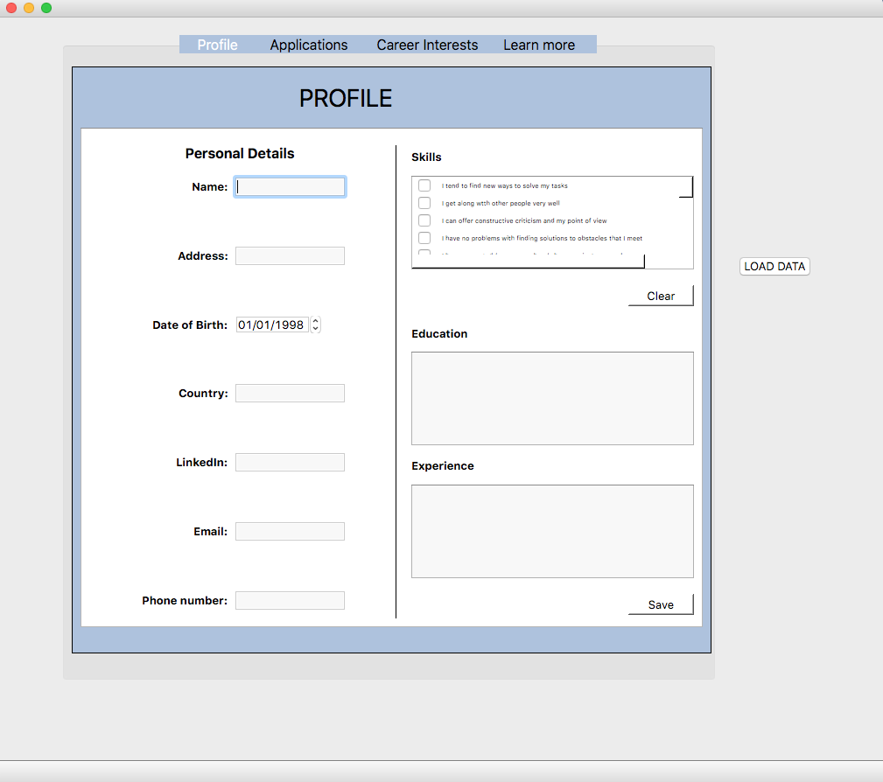

The profile page grants the user the ability to produce their professional profile, this will help them produce a professional identity and give them direct access to all their professional information should they need it.

[Final version should include these instruction sorroundinf the image of the page]

* On the left the user should fill in their personal and proffessional information.
* Top-right, the user can select multiple skills that relate to them. Should they wish to start again and select new skills, there is a ‘Clear’ button underneath.
* Below the skills section is the ‘Education’ section. Within this box, the user can write-out all their previous and current education history.
* Similar to the education box, the user can input their employment history within the ‘Experience’ section.
* Next the user should click the ‘Save’ button, to ensure they don’t lose their information upon restarting the program.
* On the right of the centre window, is a ‘Load Data’ button which will load all the previously inputted information from a local database.

## Application Pages

**Add Job Page:**

**This section will allow you to add any job applications you have made, either online or in-person.**

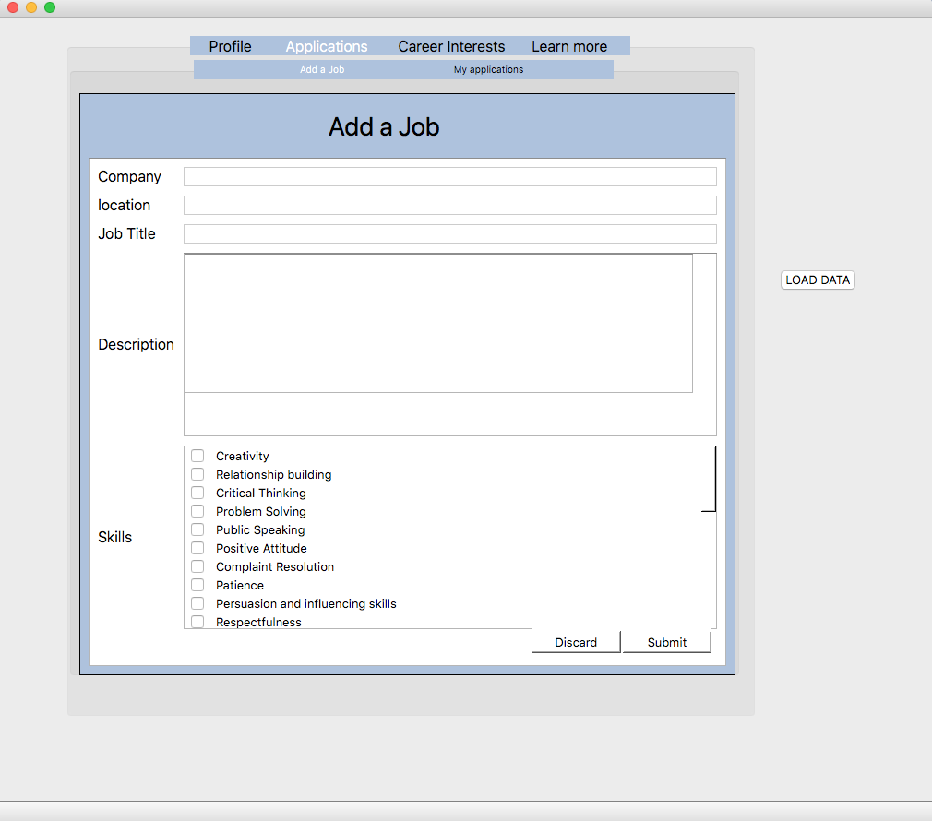

* To start the user can include the name of the company offering the role.
* Secondly the title of the role, i.e Software Engineer, Customer Service Assistant, etc.
* Include location of role.
* Here you can produce a description of the role. If this application was discovered online you could simply copy and paste information from the advertisement, along with some useful notes on the role.
* you can check which skills apply to this role.
* Next you can either discard the application or click ‘Submit’ to save the job into ‘my applications’

**My Applications Page:**

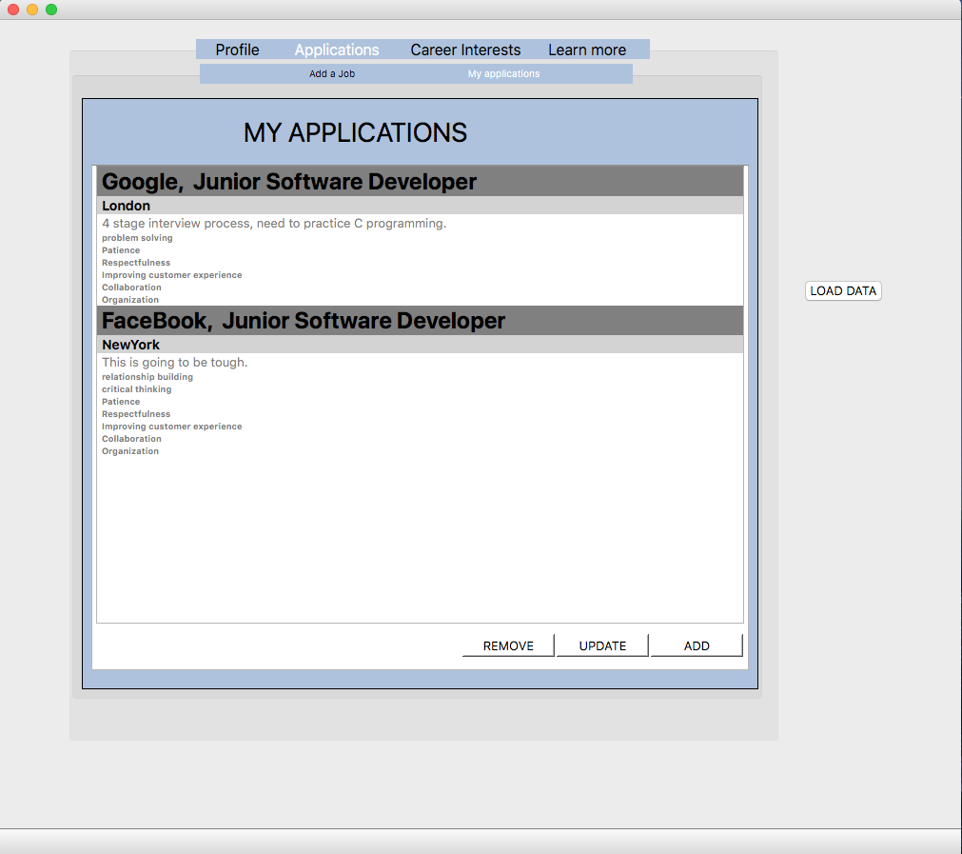

On this page the user can keep track of their previously added applications

* You can remove an application
* Update the application with any new or relevant information
* or you can even add a new application.

## Careers Interest Page

## Macintosh HD:Users:aidanbroomfield:Desktop:Screen Shot 2021-04-13 at 19.29.11.png

This page includes four tabs, which help

* The first section allows the user to input the name of employers they deem interested in for their future.
* Once the employers name has been inputted, the user only has to clicked the ‘Add’ button. Then the employers name will be listed below.

This process is exactly the same for the ‘Sectors’, ‘Job types’ and ‘Interest Areas’ tabs.

## Learn More Page

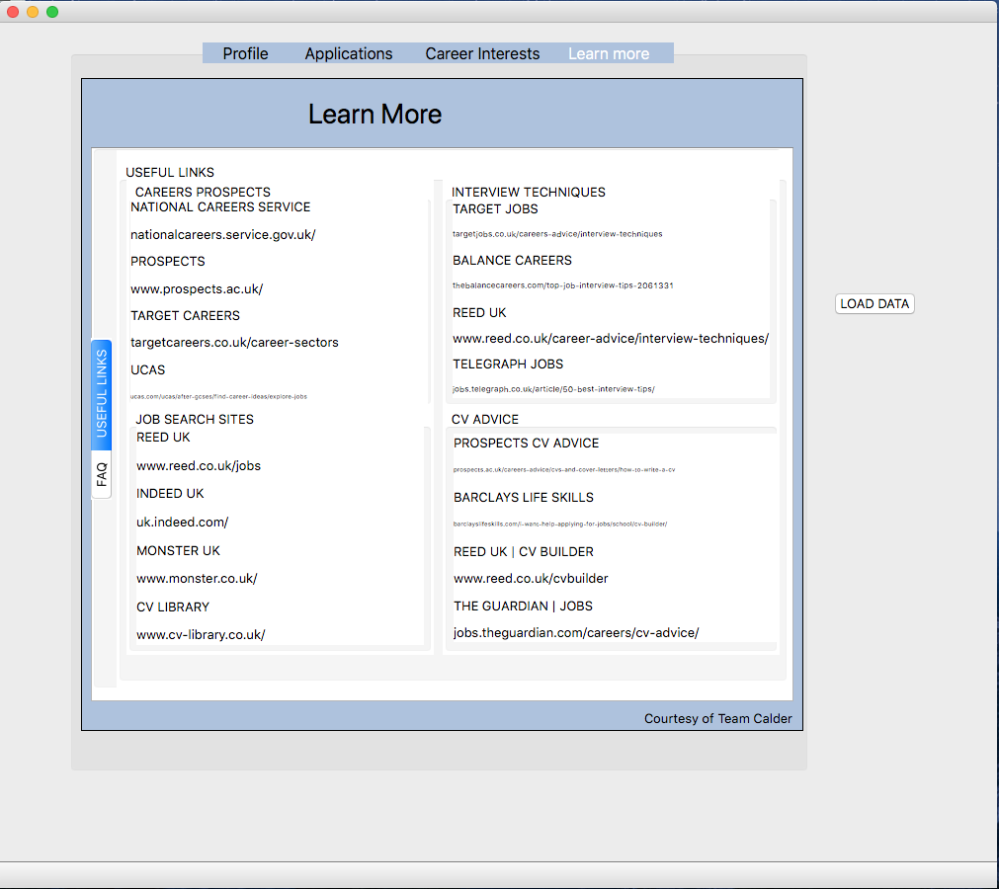

Should the user not have much experience in starting a career, the software has an entire section dedicated to providing the user with a ‘Useful Links’ page, where they can make use of dozens of links to job advice and search sites, also should the user have any issues or questions about the software, there is a ‘Frequently Asked Questions’ section for them to read through

# Data structures and Algorithms

## Overview of Coding Approach

## Using PyQt5 to build a GUI

For the implementation of our designs, we used PyQt5. PyQt is a software plugin which offers a simplistic platform to design python programs. It allows for the building of programs written in code or through a drag and drop GUI layout. This was a design choice we made as group members had different experience levels within python. It allowed for the quick progression from UI designs to actual working pages of the application we wanted to build.

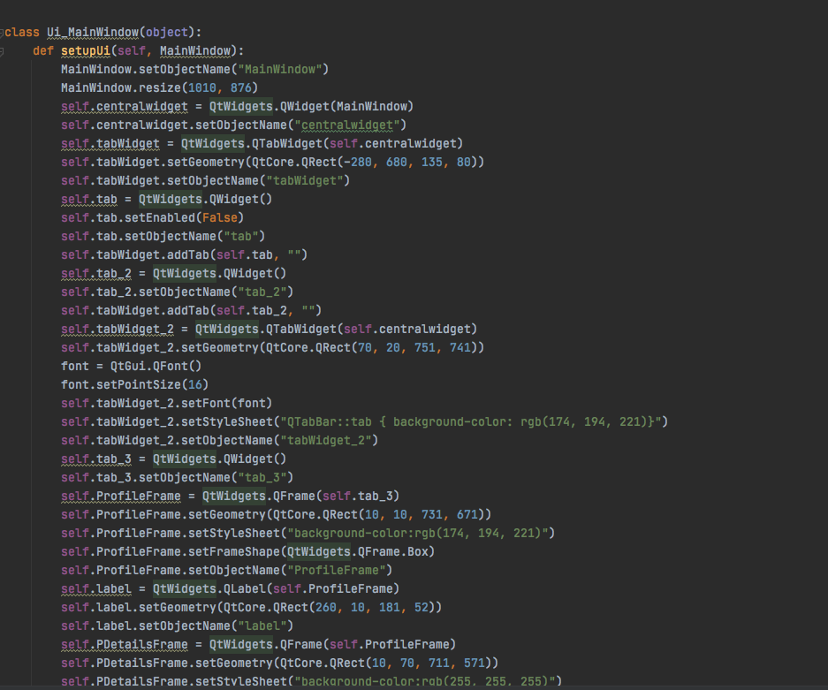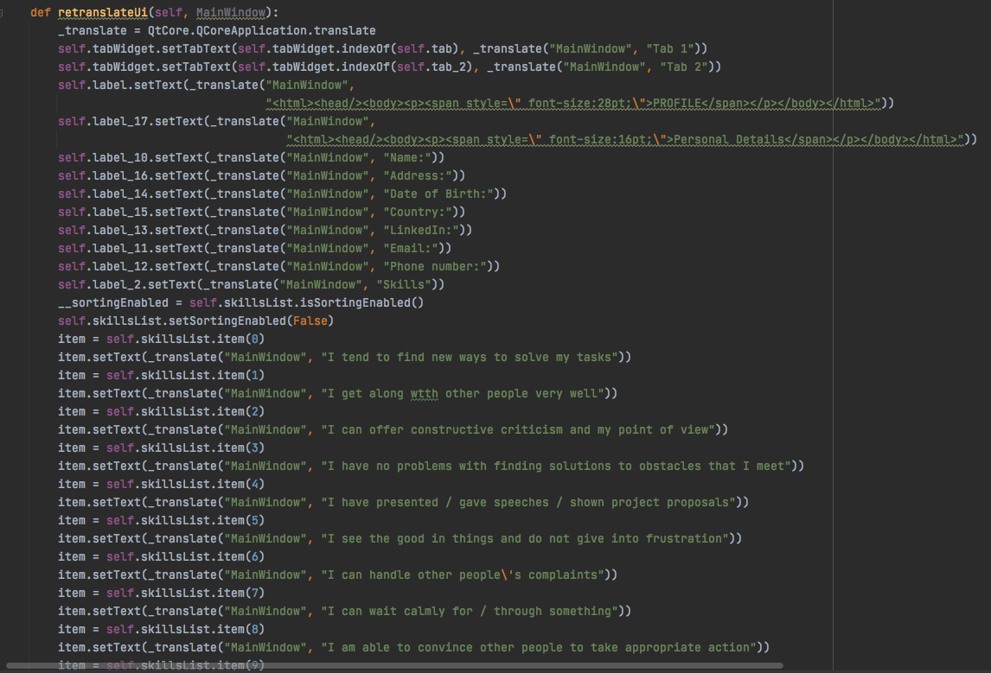

## Profile Page Functions

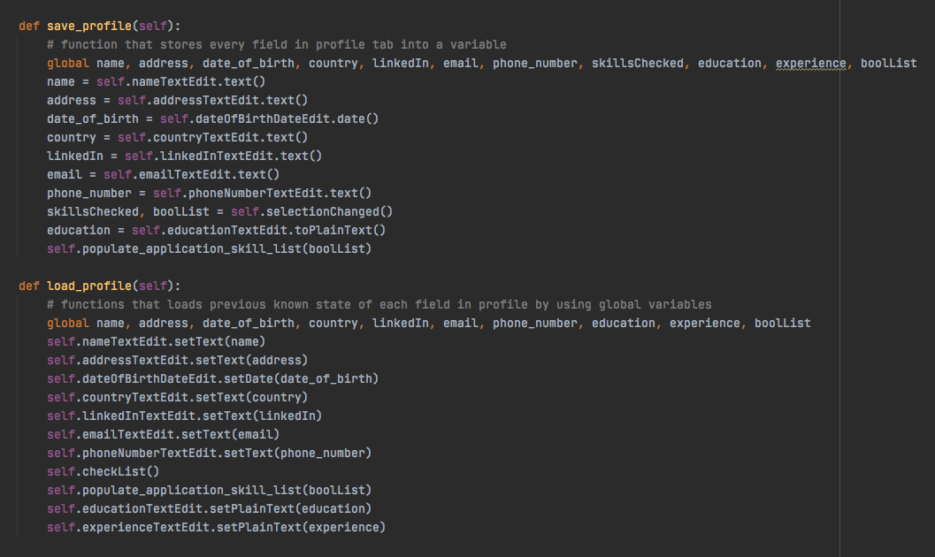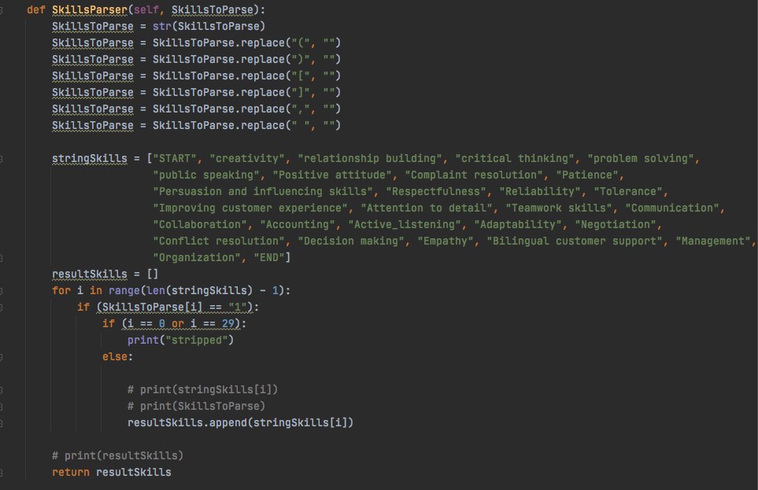

## Application Pages Functions

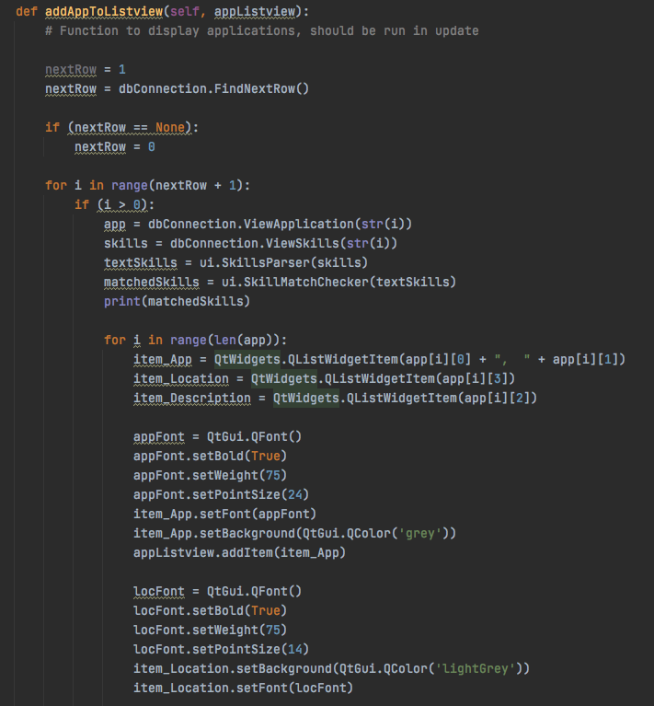

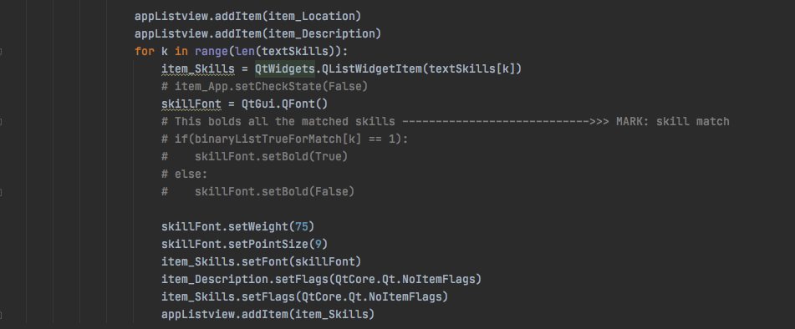

# Verification and Testing

For the testing aspect of our project, we created a test specification which we then used as guidance in forming our Product Backlog, therefore in turn our Sprint Backlog.

|  |  |  |  |  |  |  |
| --- | --- | --- | --- | --- | --- | --- |
| **Test Reference** | **Test Content** | **Input** | **Expected Outcome** | **Actual Outcome** | **Pass Criteria** | **Pass / Fail** |
| **TFR1.1** | **A link is provided.** | **Open application, Navigate to Learn More Page.** | **One or more links are present.** |  | **A link is provided.** |  |
| **TFR1.2** | **The link re-directs the user to the page.** | **One of the links is “Clicked”.** | **The user is re-directed to a webpage.** |  | **The user is re-directed to the correct webpage.** |  |
| **TFR2.1** |  |  |  |  |  |  |
| **TFR35.1** | **The user can add a job application, to Applications** | **On the Addjob page, fill in details and “Click” submit.** | **The details are filled in and submitted.** |  | **The details can be filled in and submitted.** |  |
| **TFR35.2** | **The Applications are saved.** | **On the Addjob page, fill in details and “Click” submit.** | **The details are filled in and submitted and saved to the database.** |  | **The database updates it’s records containing the latest application.** |  |
| **TFR35.3** | **The applications can be displayed.** | **Open application, navigate to the Applications page.** | **Applications are displayed here.** |  | **Applications are visible to the user.** |  |
| **TFR35.4** | **Saved applications can be displayed.** | **Open application, navigate to the Applications page.** | **Previously saved applications are displayed.** |  | **Only saved applications are displayed.** |  |
| **TFR35.5** | **Only valid data is stored in each field.** | **At the Addjob page enter “-100” in every field and “click submit”.** | **A pop-up will ask the user to re-enter the information.** |  | **The user must re-enter the in-valid information.** |  |
| **TFR35.6** | **Only valid data is stored in each field.** | **At the Addjob page enter “&” in every field and “click submit”.** | **A pop-up will ask the user to re-enter the information.** |  | **The user must re-enter the in-valid information.** |  |
| **TFR35.7** | **User can change the status of an application.** | **At the application page, select an application’s status, drop-down bar, change the status from “Haven’t applied” to “Applied”** | **The status of the application will be updated and shown.** |  | **The status reflects the user’s decision.** |  |
| **TFR.35.8** | **User can change the status of an application and save it to the database.** | **At the application page, select an application’s status, drop-down bar, change the status from “Haven’t applied” to “Applied”, then “Click” update.** | **The status of the application will be saved to the database and displayed.** |  | **The status is saved to the database.** |  |
| **TFR4.1** | **The user can select their skills.** | **Open application, navigate to profile page. Skills are selected using tick boxes.** | **Boxes can be checked.** |  | **Selected skills checkboxes are ticked.** |  |
| **TFR4.2** | **The user can un-select their skills** | **Open application, navigate to profile page. Skills are selected using tick boxes, and can be un-selected.** | **Boxes are checked and unchecked.** |  | **The user can Uncheck previously checked boxes.** |  |
| **TFR4.3** | **Users skills are saved.** | **Open application, navigate to profile page. Enter details and “Click” save button.** | **Profile is saved.** |  | **The data is saved.** |  |
| **TFR4.4** | **Users skills can be loaded.** | **Open application, navigate to profile page.** | **The previously selected skills are shown.** |  | **The previous skills and details are loaded to the user.** |  |
| **TFR4.5** | **Loaded profile can be changed.** | **Open application, navigate to profile page. Change a detail or skill, and “Click” save.** | **The previous details are shown, and can be manipulated.** |  | **The changed details are then saved appropriately.** |  |
| **TFR4.6** | **Only valid data is stored in each field of personal details.** | **At the profile page enter “-100” in every field and “click submit”.** | **A pop-up will ask the user to re-enter the information.** |  | **The user must re-enter the in-valid information.** |  |
| **TFR4.7** | **Only valid data is stored in each field.** | **At the profile page enter “&” in every field and “click submit”.** | **A pop-up will ask the user to re-enter the information.** |  | **The user must re-enter the in-valid information.** |  |
| **TFR6.1** | **Applications can be filtered by location.** | **Open application, navigate to Application page. Select location drop down, “select” Aberystwyth.** | **Applications located in Aberystwyth are displayed.** |  | **Only applications located in Aberystwyth are displayed, nothing else.** |  |

# Future Work and Improvements

Some areas for improvement within our application include the following.

The first would be allowing for multiple users to access the applications services. The brief of the project did not request this, yet we thought that it would be the next stepping stone in building a stronger application.

Therefore a login page would also be a good development, as it would allow for the authentication and identification of the multiple users. It would also be a good idea so as to ensure that even if it were maintained as a single user platform, that there was some form of security upon the application.

REFERENCES

­­[1] *-‘Career Advice | Career Key’. Career Advice | Career Key, https://www.careerkey.org. Accessed 13 Apr. 2021.*

[2] - *Home : Occupational Outlook Handbook: : U.S. Bureau of Labor Statistics. https://www.bls.gov/ooh/. Accessed 13 Apr. 2021.*

[3] - *MyPlan.Com : Home. https://www.myplan.com/. Accessed 13 Apr. 2021.*

[4] *-‘Project Planning’. The Balance Careers, https://www.thebalancecareers.com/project-planning-4161724. Accessed 13 Apr. 2021.*

[5] -*‘The Career Project: “Inside Scoop” Career Profiles, Interviews & Job Info’. The Career Project, https://www.thecareerproject.org/. Accessed 13 Apr. 2021.*

DOCUMENT HISTORY

| *Version* | *Date* | *Changes made to document* | *Changed by* |
| --- | --- | --- | --- |
| 1.0 | 4/02/21 | N/A - original version | AIB17 |
| 2.0 | 05/03/21 | Updates to all main areas | AIB17 |
| 3.0 | 07/04/21 | Addition of User Manual | SEC24 |